First HALF of DSF generates upswing
in economic activity

Dubai, UAE 18 January 2017: The first half of Dubai Shopping Festival 2017 has led to an upswing in activity across various sectors in Dubai including retail, hospitality and financial services, and given a boost to ancillary services such as money exchange houses and travel agencies.

Shopping malls, international brands and hotels, as well as travel operators, exchange houses and many other support services have been making the most of the festival’s 22nd edition, which started on 26 December and runs until 28 January, offering residents and visitors an enriching shopping experience created by a combination of incredible deals, life-changing prizes and world-class entertainment.

Organised by the Dubai Festivals and Retail Establishment (DFRE), an agency of the Department of Tourism and Commerce Marketing (Dubai Tourism), the festival is giving visitors the opportunity to ‘Shop. Win. Celebrate’ through special retail experiences featuring promotions and events that have the active participation of people from all nationalities and cultural backgrounds.

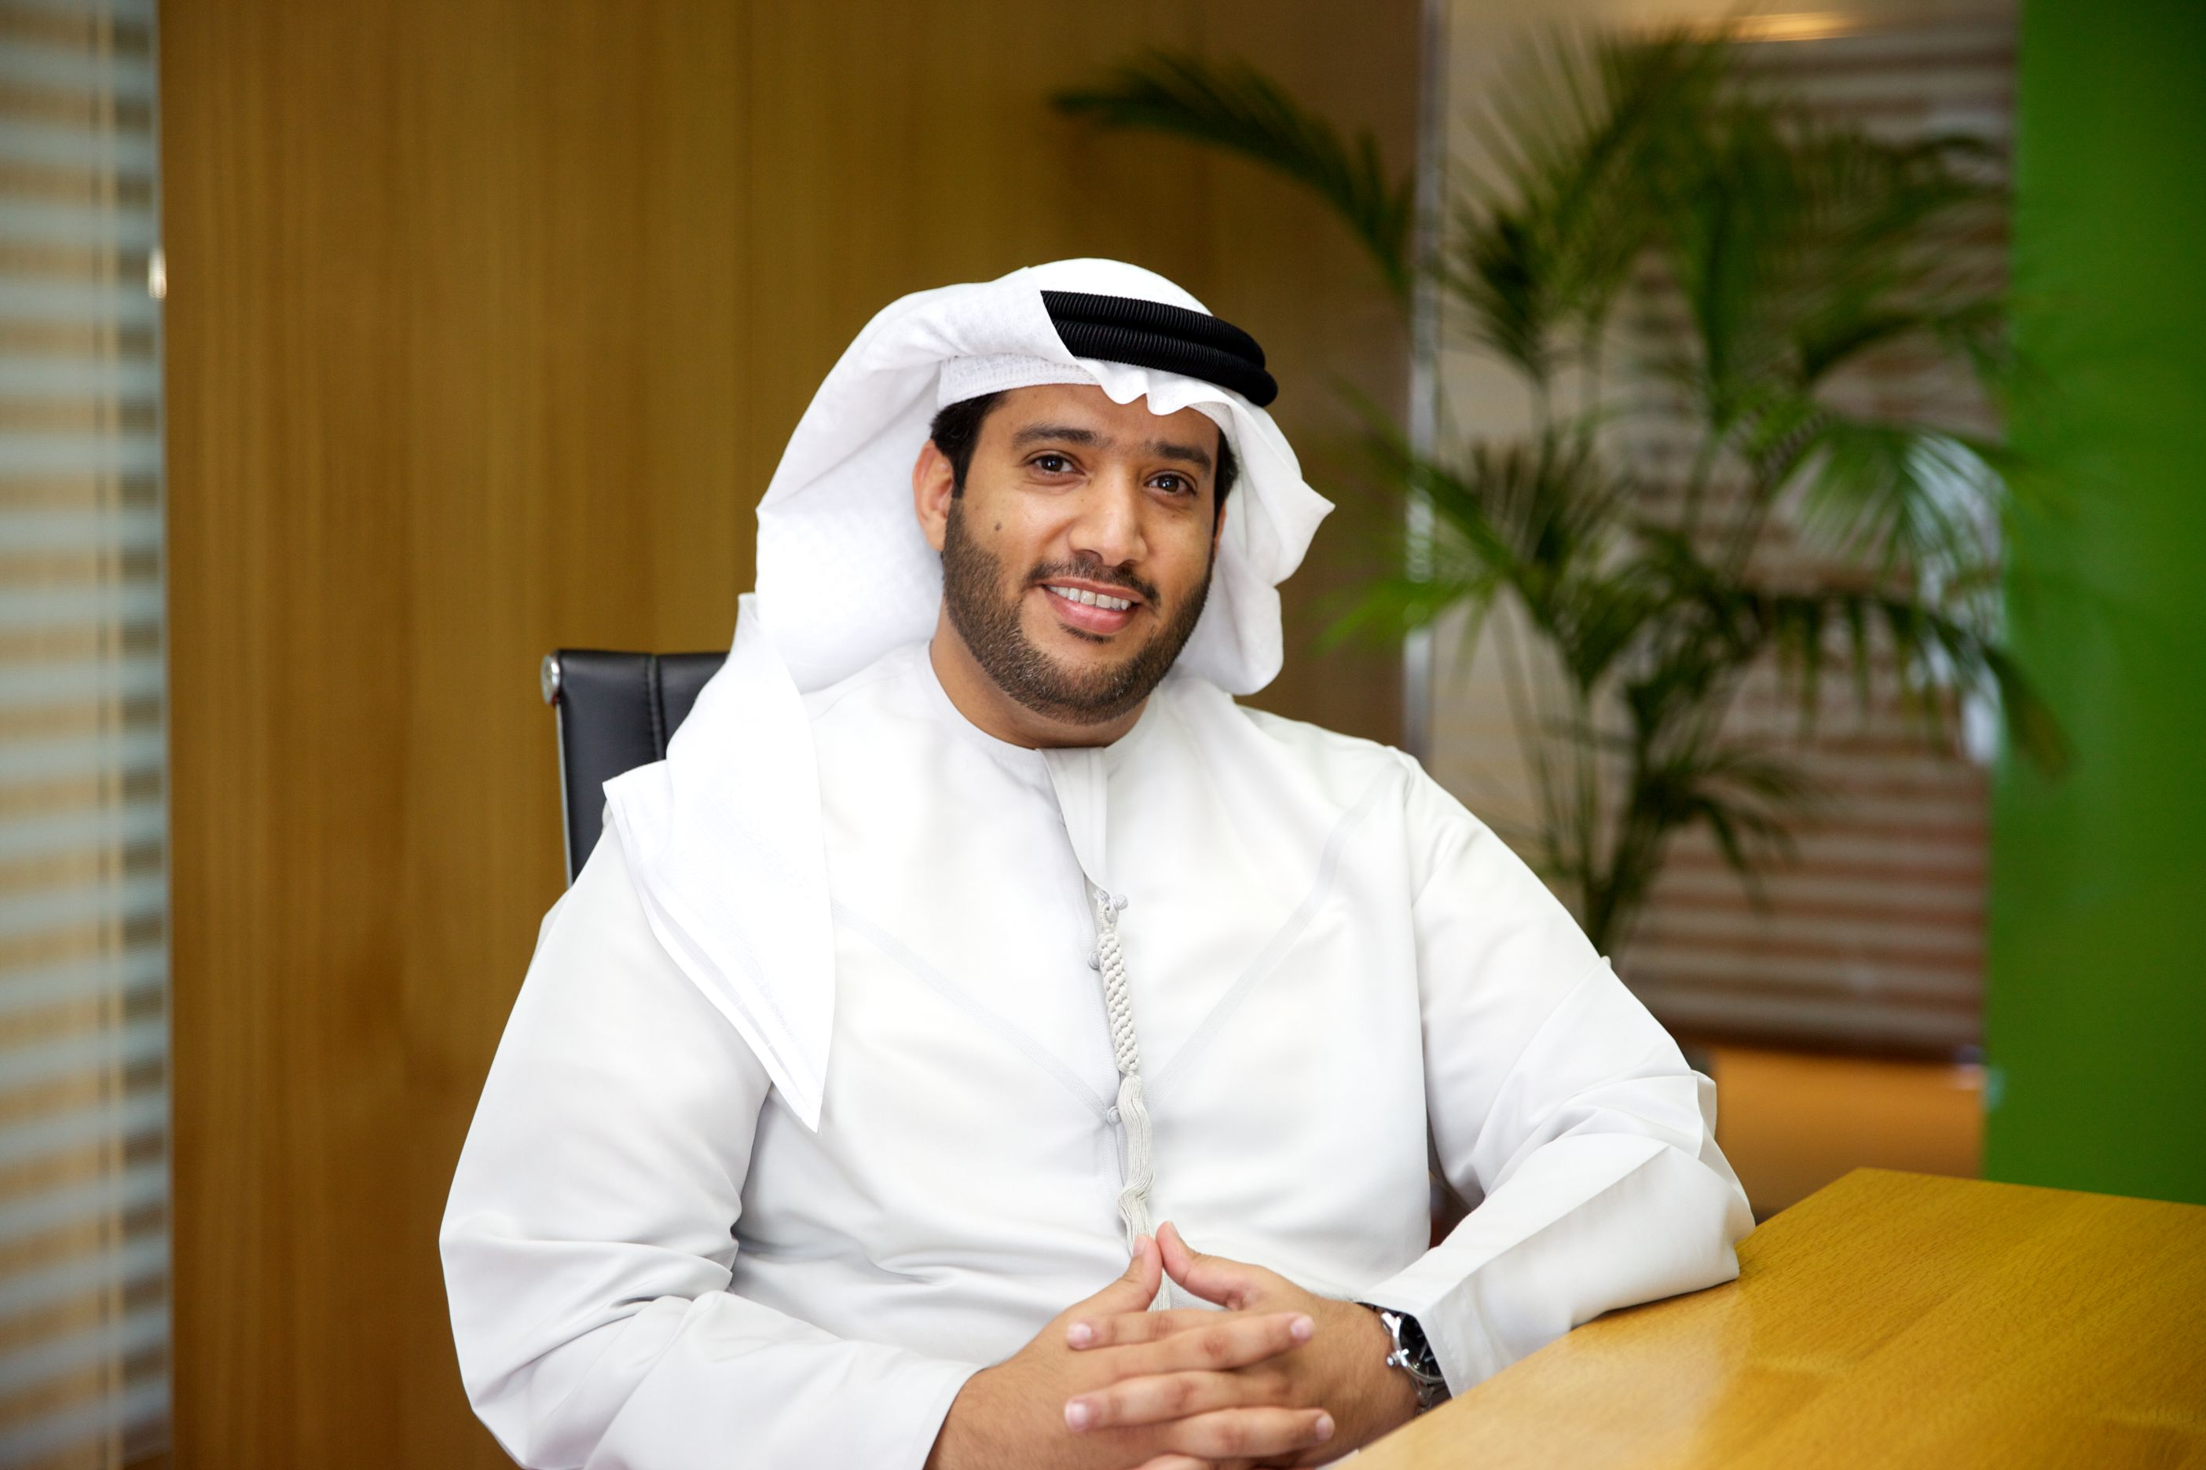

Commenting on the good showing across various sectors in Dubai, Saeed Mohammad Al Falasi, Executive Director, Retail and Strategic Alliances, DFRE, said: “With Dubai Shopping Festival crossing its halfway mark, key economic sectors have reported improved performances, giving Dubai’s retailers a great start for 2017. As an engine of growth for the retail sector in Dubai, DSF has also given a boost to various other sectors including hospitality, travel and financial services. The success achieved in just over two weeks of the Dubai Shopping Festival further validates our strategy to start earlier than usual to coincide with the festive and holiday season and the winter vacation for schools, leading to more business for retailers.

“The positive impact that the festival has made at its halfway stage is also ample testimony to the spirit of cooperation and excellent work being done by the different government departments and the private sector to continue enhancing the emirate’s position as a leading tourism destination offering unique shopping experiences.”

Malls and thousands of retail outlets have recorded sharp increases in footfall, as DSF shoppers avail themselves of discounts of up to 75 % on a wide range of merchandise including electronics, home appliances, computers, perfumes, cosmetics and fashion. Since the start of the festival, families have been flocking to DSF’s key attractions at several locations in Dubai including the Carpet and Art Oasis and Global Village. Tourists have also taken advantage of the best rates that are being offered by money exchange dealers while travel agencies have been busy coping with an upsurge in visitors.

GOLD & JEWELLERY SECTOR SPARKLES

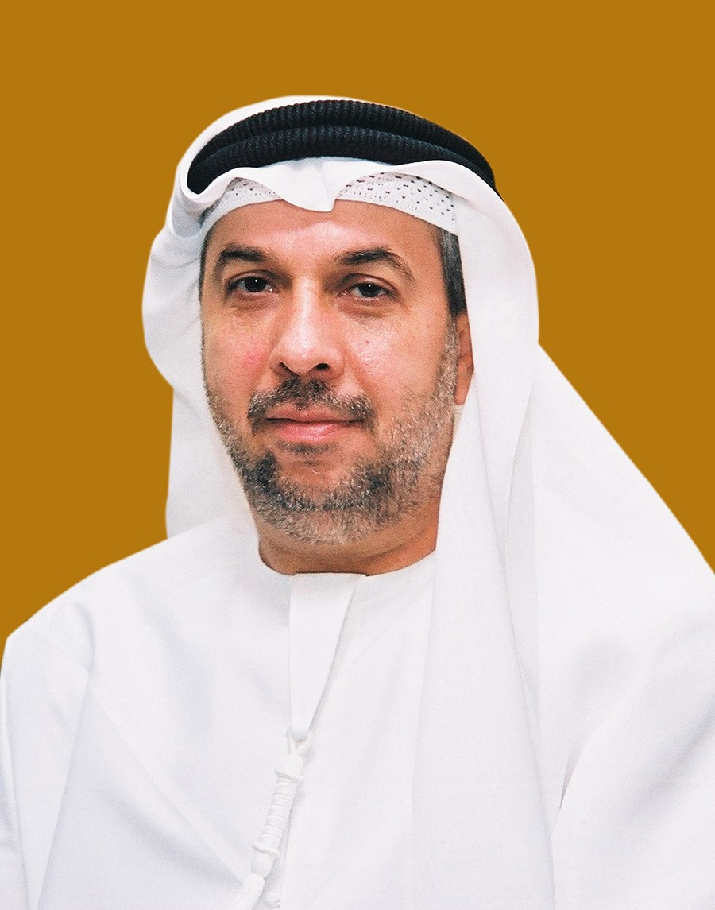

Tawhid Abdullah, Chairman, Dubai Gold & Jewellery Group, said: “2017 opened with a very positive note for jewellers as they are witnessing an impressive sale season in connection with the Dubai Shopping Festival. The jewellery sector managed to pull in greater footfall into the jewellery stores during the last two weeks and this has translated into an increase in the average value per transaction compared with what it was during the previous three months. Comfortable pricing of gold has also been a major positive factor for incremental business. Based on an analysis we conducted in the midway of DSF, we observe that the participating jewellery outlets witnessed a considerable growth in sales volume (both in ticket size and number of transactions) during the group promotion compared to the previous year and the figure is steadily growing. 34 kilos of gold is a big winning proposition and this year, three lucky winners get to take home gold every day. Shoppers are eagerly looking forward to this life-changing opportunity.”

Shopping Malls

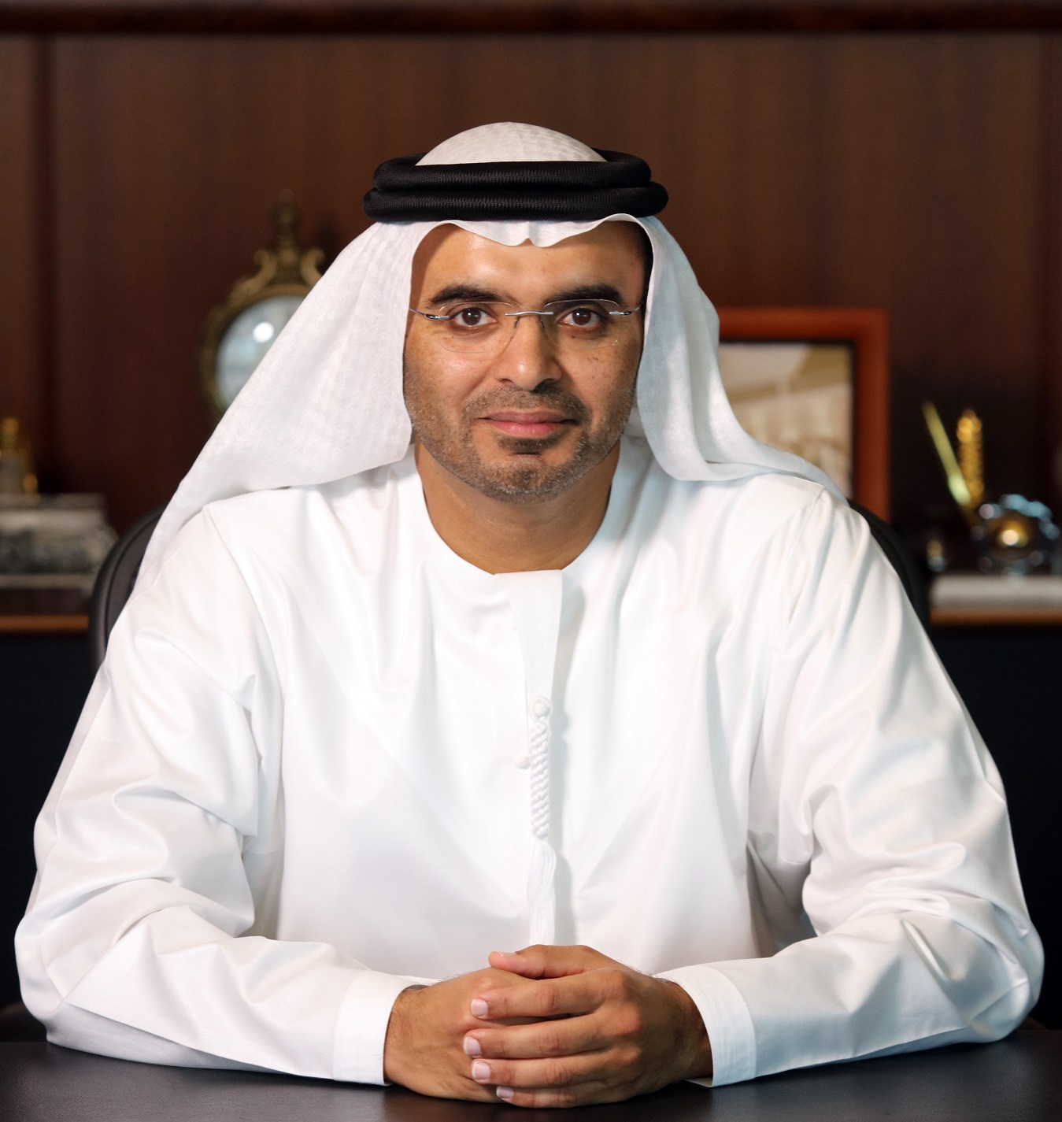

Mr. Majid Al Ghurair, Chairman of Dubai Shopping Malls Group, said: “The early signs of Dubai Shopping Festival are encouraging, with a large number of visitors travelling to Dubai to enjoy the festivities and shopping season. DSF and DSMG’s offerings are warmly welcomed and make Dubai a hotspot in the region for tourists and residents. The shop and win - ‘Happy Shopping, Happy Winning’ - campaign has helped increase sales within the 19 participating malls which are reflected by the surge in a number of raffle coupons.
“Going forward we foresee an increase in footfall and sales aided by the regional holidays coming up across GCC. We are expecting a good inflow of tourists from neighbouring countries - we hope to impart a full-filling shopping experience for all those who visit us.”

The Dubai Mall

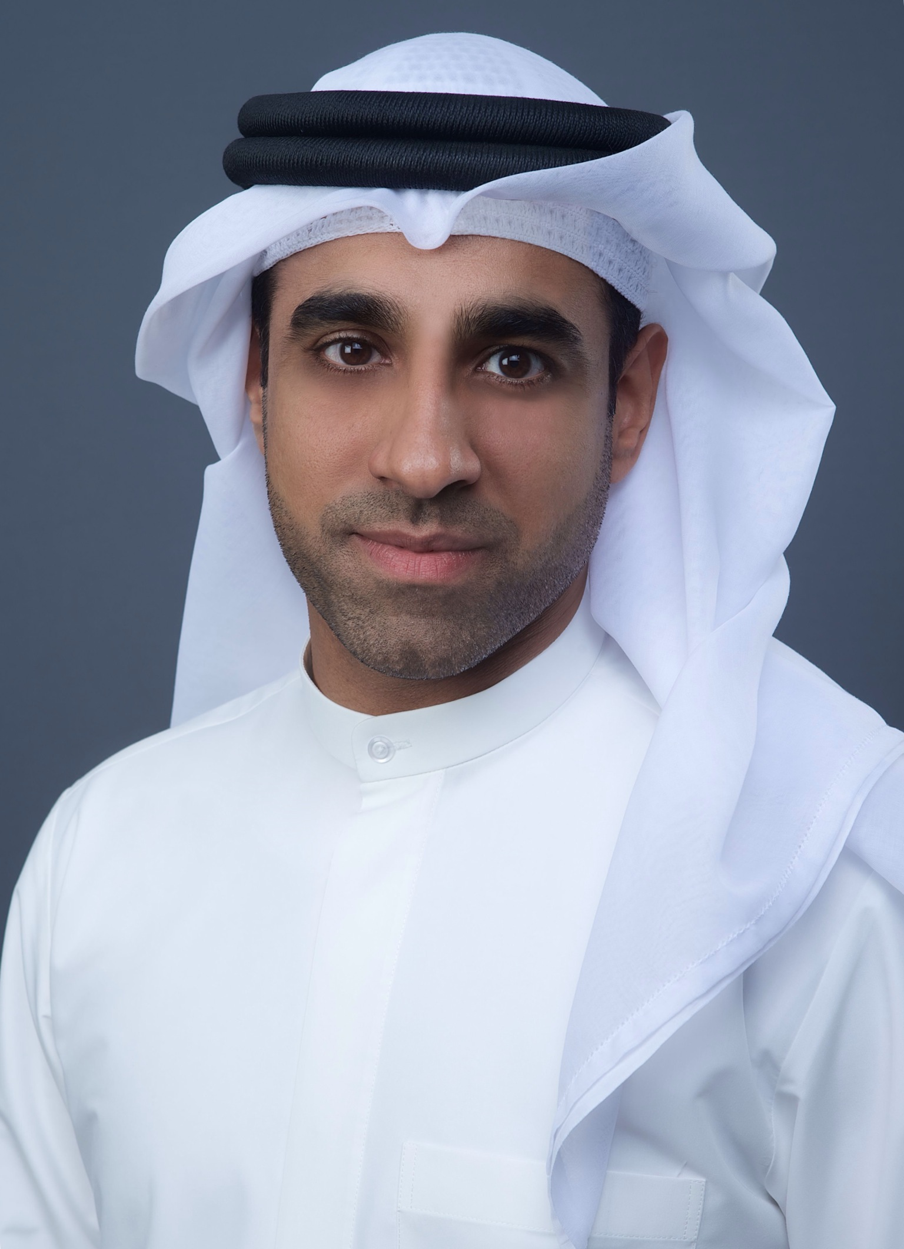

Nasser Rafi, Chief Executive Officer of Emaar Malls, said: “Dubai Shopping Festival has once again energised the retail sector of Dubai, and is contributing significantly to the economy in driving tourist growth and supporting the aviation and hospitality sectors. As its strategic partner, Emaar Malls has recorded robust growth in tourist arrivals with our retailers reporting positive growth in business. As we reach the halfway mark of the festival, we look forward to seeing continued strength in visitor numbers to our malls, further underpinning the importance of the event to the growth of Dubai’s retail sector.”

Majid Al Futtaim Properties (City Centre Deira, City Centre Mirdif, City Centre Me’aisem, City Centre Al Shindagha, My City Centre Al Barsha Mall of the Emirates,)
“The 22nd edition of the Dubai Shopping Festival has been a resounding success for our six flagship shopping malls: Mall of the Emirates, City Centre Deira, City Centre Mirdif, City Centre Me’aisem, City Centre Al Shindagha and My City Centre Al Barsha with positive feedback from our retail partners and valued customers,” said Fuad Mansoor Sharaf, Senior Director – Property Management, Shopping Malls for Majid Al Futtaim.

“We have witnessed robust increases in visitation during the first two weeks of the festival period as a result of our tremendous shopping options, unique prizes and signature events such as the Teenage Mutant Ninja Turtles stage show. We look forward to delivering more Great Moments throughout the festival including the highly anticipated Fashiontainment event at Mall of the Emirates. As a Strategic Partner, Majid Al Futtaim extends its congratulations to the Dubai Festivals and Retail Establishment, for a successful start to its 22nd Dubai Shopping Festival.”

Dubai Festival City

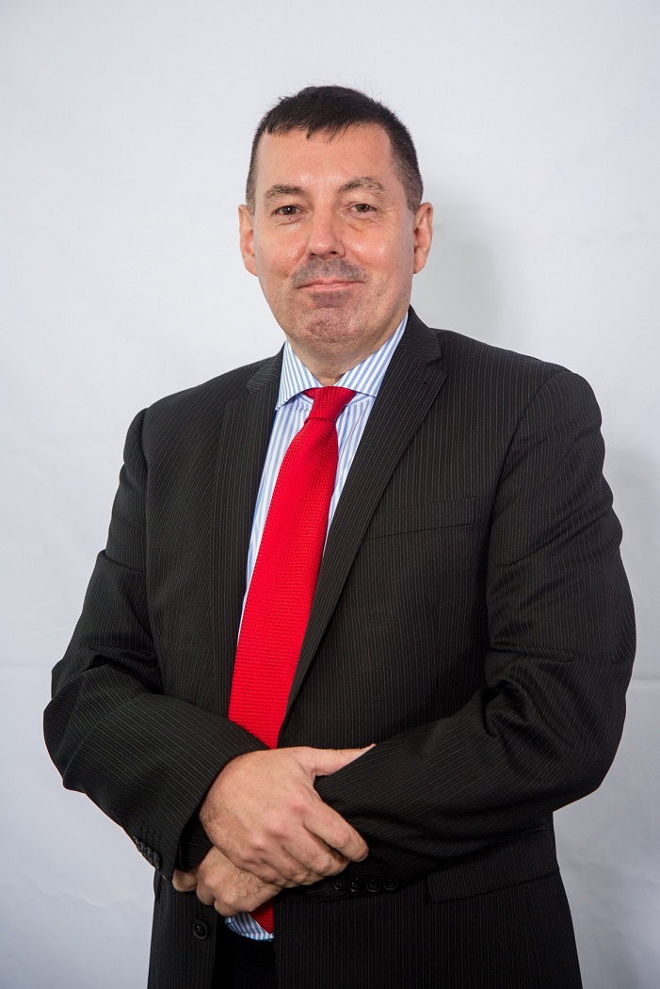

Steven Cleaver, Director Shopping Malls – Al-Futtaim Group Real Estate, said: “The 2017 Dubai Shopping Festival has been a spectacular success so far and we have seen a significant uplift in footfall across Festival City and throughout our 400 world class retailers and 75 restaurants. We are seeing a large number of people travelling not only from Dubai but also Saudi Arabia, Abu Dhabi and the northern emirates. Our visitors are looking to make the most of the DSF sales and activity, as well as come and experience our newly launched global attraction – IMAGINE. We have a number of exciting activities for the remainder of the month, from flash mobs to fashion shows, so we are expecting this positive trend to continue.

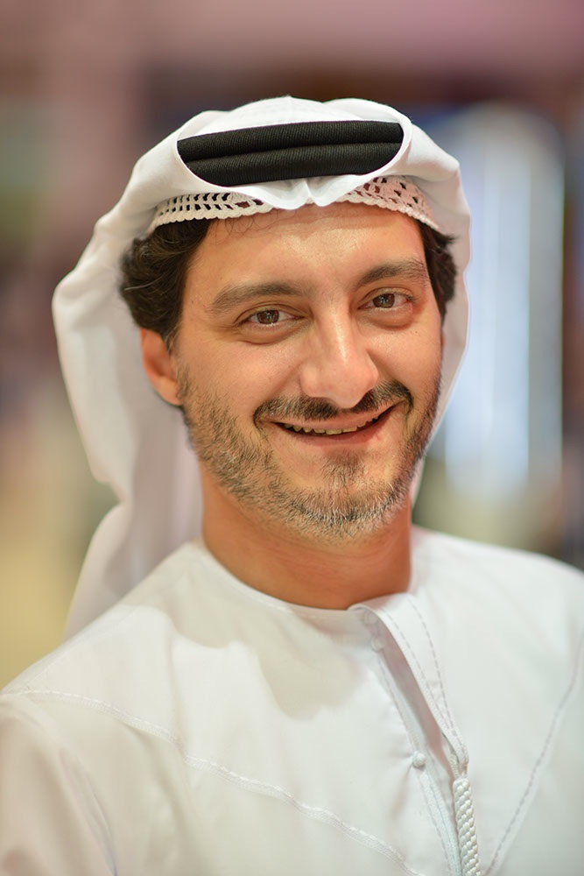

Saleh Mohamed Al Geziry, Vice President, Retail Marketing, Promotions & Recreation, Meraas, said: “During the first half of the Dubai Shopping Festival (DSF), Meraas has been running exciting activations across destinations, CITY WALK, THE BEACH, BOXPARK and The Outlet Village, including roaming entertainment, fashion shows, pop-up markets and theatrical performances.

“All destinations have received a great response to the DSF activities, with visitors keen to witness the great variety of entertainment on offer and take advantage of the fantastic shopping deals. Tenants have been happy with the footfall across the destinations, and have seen this translate into an uplift in sales. We are sure this trend will continue throughout the remainder of the festival, especially as the last two weeks are the strongest trading period.”

Nakheel Malls (Ibn Battuta Mall, Dragon Mart 2)

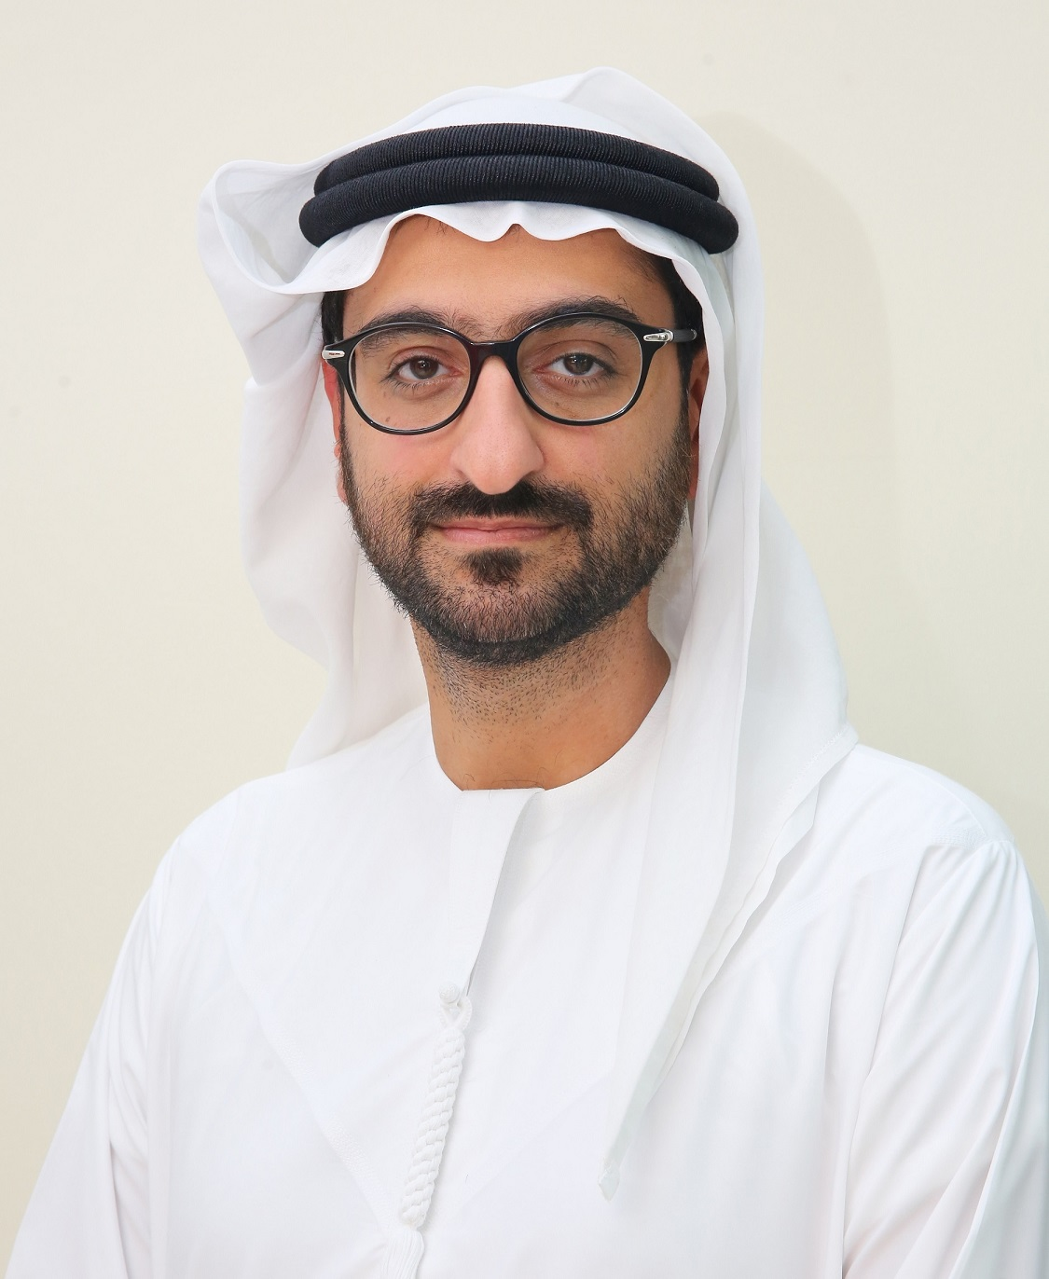

Omar Khoory, Director Nakheel Malls, said: “Nakheel Malls has seen an overwhelming response to Dubai Shopping Festival so far, with increased footfall at both Dragon Mart 2 and Ibn Battuta Mall, where we are offering a wide range of live events, attractions and promotions. As DSF coincides with Dubai’s peak tourist season, our malls are welcoming huge numbers of visitors as well people who live in the emirate. We anticipate further positive activity as DSF gathers even more momentum over the remaining two weeks of the festival.”

Mercato

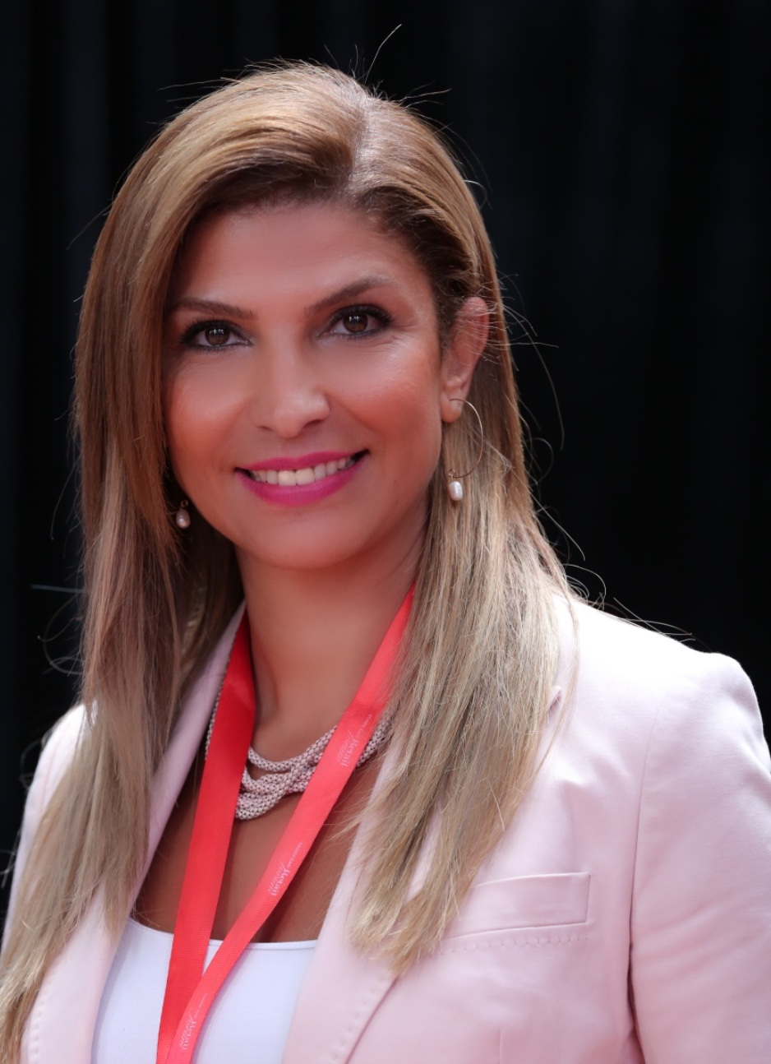

Nisreen Boustani, PR and Corporate Communication Manager at Mercato & Town Centre Jumeirah, said that Mercato received a very positive response during the first two weeks of DSF.

“DSF has always been a unique platform offering home-grown, regional and international brands the opportunity to introduce new products and collections during the festival. In addition to the traditional unbeatable deals and promotions, DSF has now evolved into a 34-day event where retailers are able to use this period to introduce new concepts and activities. We have noticed an increase in the mall’s footfall during the first half of DSF 2017 compared to the same period last year during DSF 2016”.

“The Italian carnival live entertainment and exciting ‘Shop and Win’ promotions have certainly played a major role in attracting more tourists from different European countries, as well as from Asian and GCC countries and local residents who can benefit from the considerable price reductions across many stores in the mall,” she added.

Retail

Paris Gallery

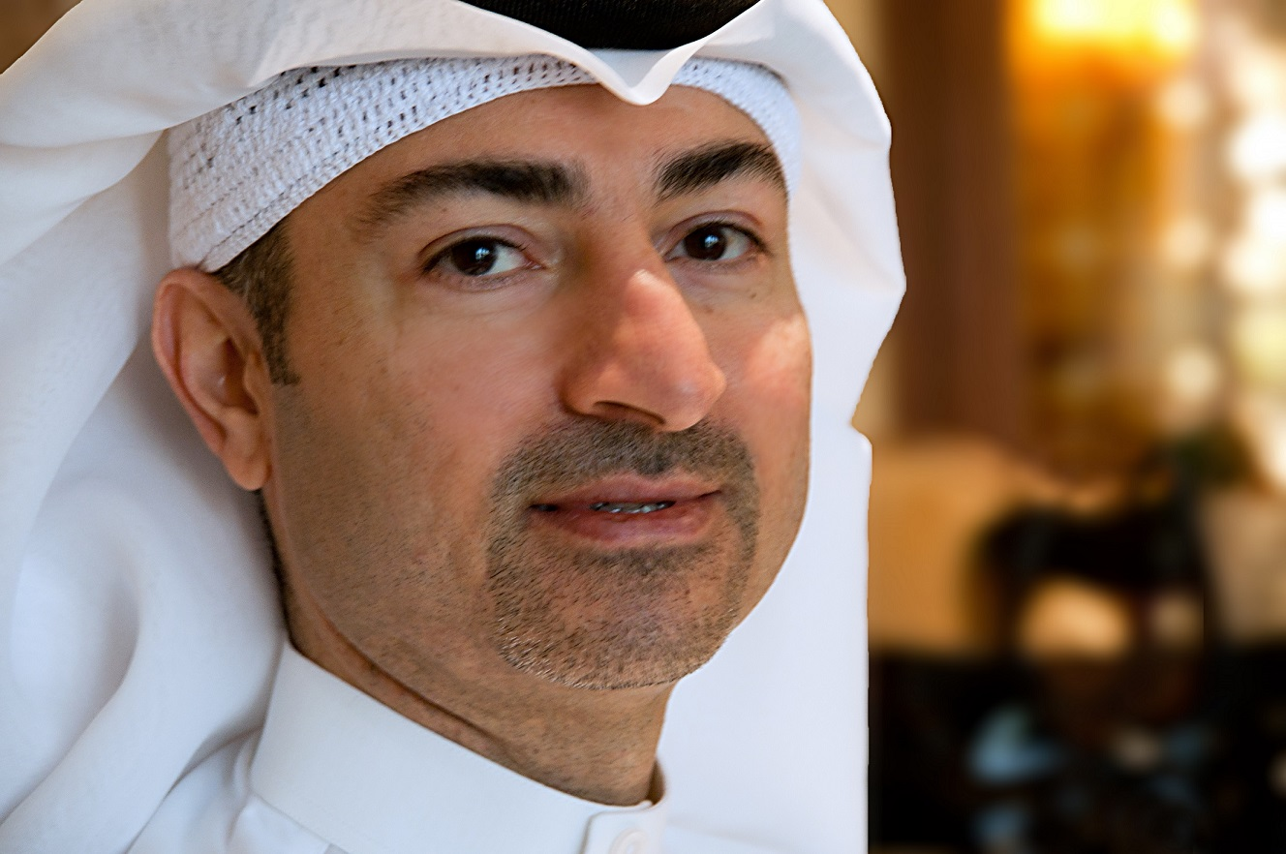

Mr. Mohammed Abdul Rahim Al Fahim, CEO of Paris Gallery Group of Companies, said: : “DFRE has once again played a positive and constructive role in working alongside malls and other related sectors to make shopping, entertainment and leisure exciting and rewarding for visitors and residents. The festivities of DSF 2017 in the country which includes grand offers, prizes, and continuous entertainment have been one of the major reason for a spike in sales. Sales have increased at Paris Gallery beginning with the holiday season and then into the DSF month with both tourists and residents shopping for gifts and taking advantage of great deals. We are witnessing heightened customer engagement in our stores and average sales increase across all our stores is about 8%. We hope to see this continue throughout the month. We are making sure everyone has a memorable time shopping with us during this festive season by availing special offers that include corporate promotions and special gifts from brands.

Jumbo Group

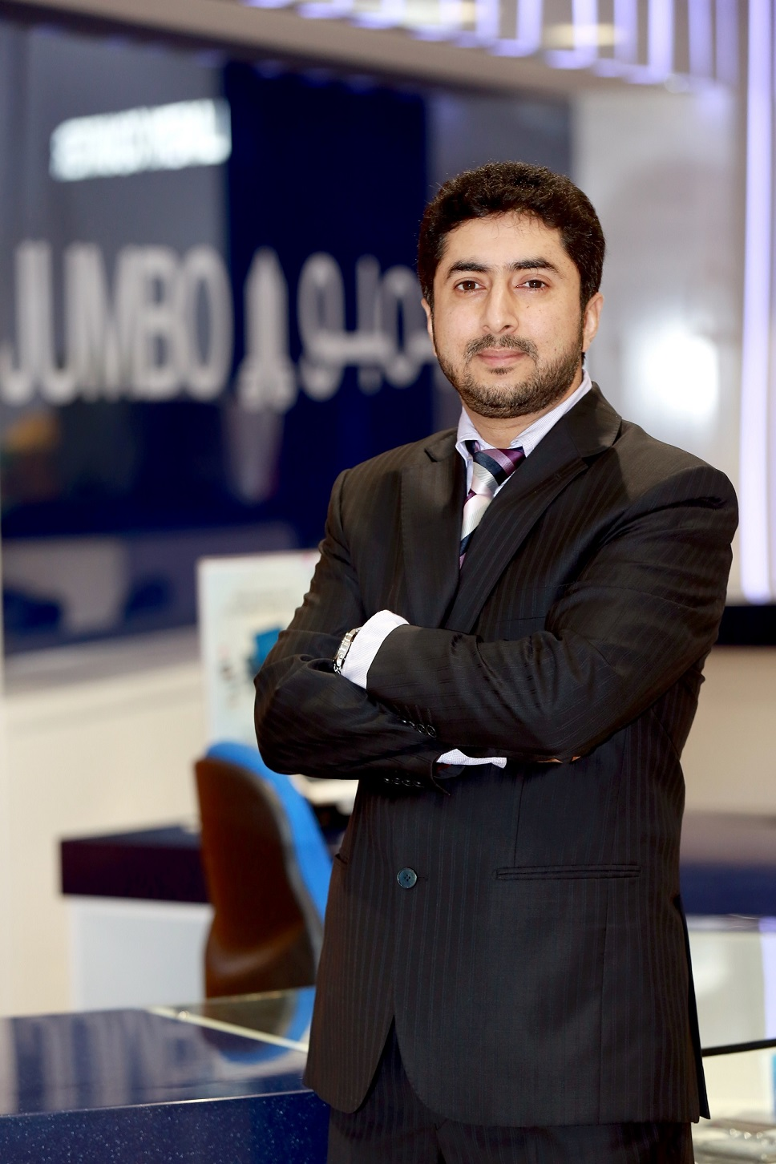

Nadeem Khanzadah, Head - OmniChannel Retail at Jumbo said: “The 2017 DSF started on 26th December 2016, a week earlier than usual. We think it was a great strategy to attract the tourists visiting Dubai to experience shopping during DSF. We had planned our offers and marketing to specifically cater to this floating population of UAE, and we are on target for that. Until now we have seen a double digit growth in our performance as compared to last year with key drivers being Smartphones, VR headsets and super large 4K TV's but with the resident population returning and the tourists, we are confident that over the next two weeks we will definitely see an even more healthier growth.”

Arabian Automobiles

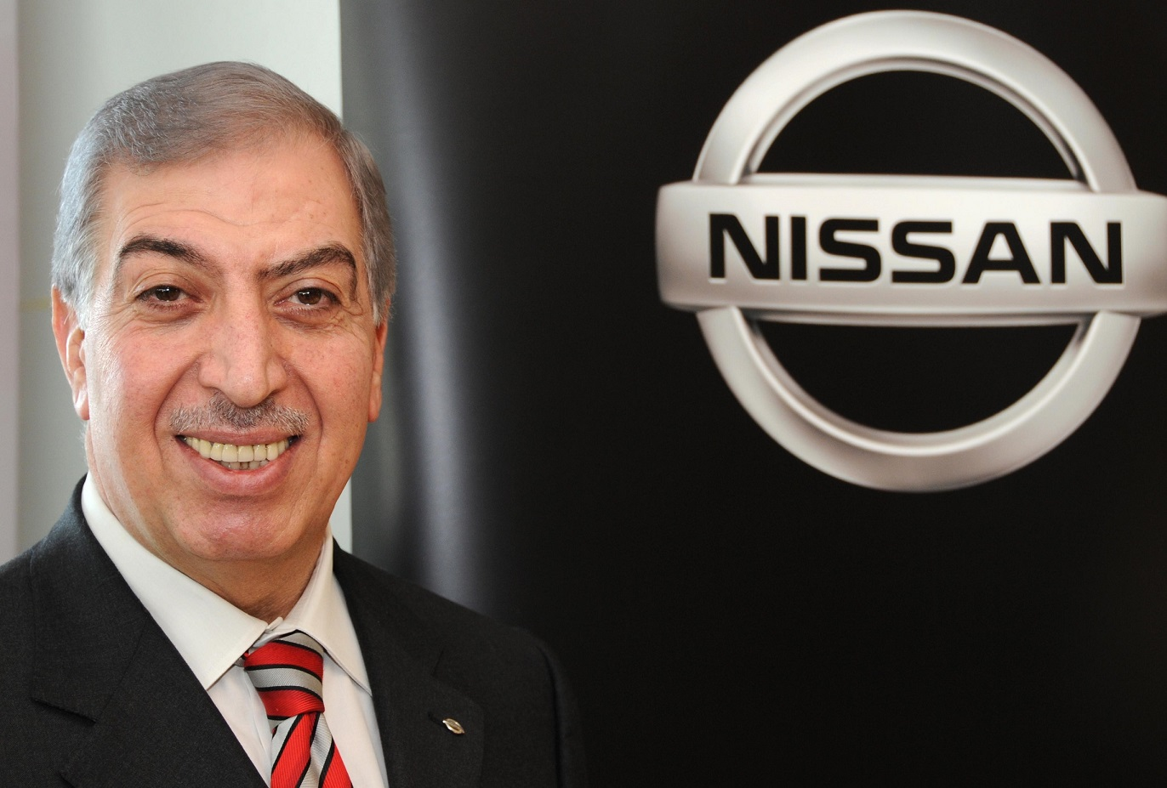

Michel Ayat, CEO of Arabian Automobiles Company – the flagship automotive division of AW Rostamani Group and exclusive dealer for Nissan, Infiniti and Renault in Dubai and the Northern Emirates – said: “We are delighted to support the important government initiatives that promote Dubai as a global tourism destination for both its residents and visitors. Since its inception 22 years ago, we have enjoyed a continuous and strategic relationship with Dubai Festivals and Retail Establishment, and together we offer exciting annual retail opportunities for both shoppers and brands.”

Michel added: “Arabian Automobiles Company will bring a range of exciting promotional campaigns to Dubai Shopping Festival 2017, through our popular car brands Nissan, Infiniti and Renault. It is a unique opportunity for us to demonstrate our commitment to our customers, and to thank them for their ongoing loyalty, confidence and support.”

ENOC

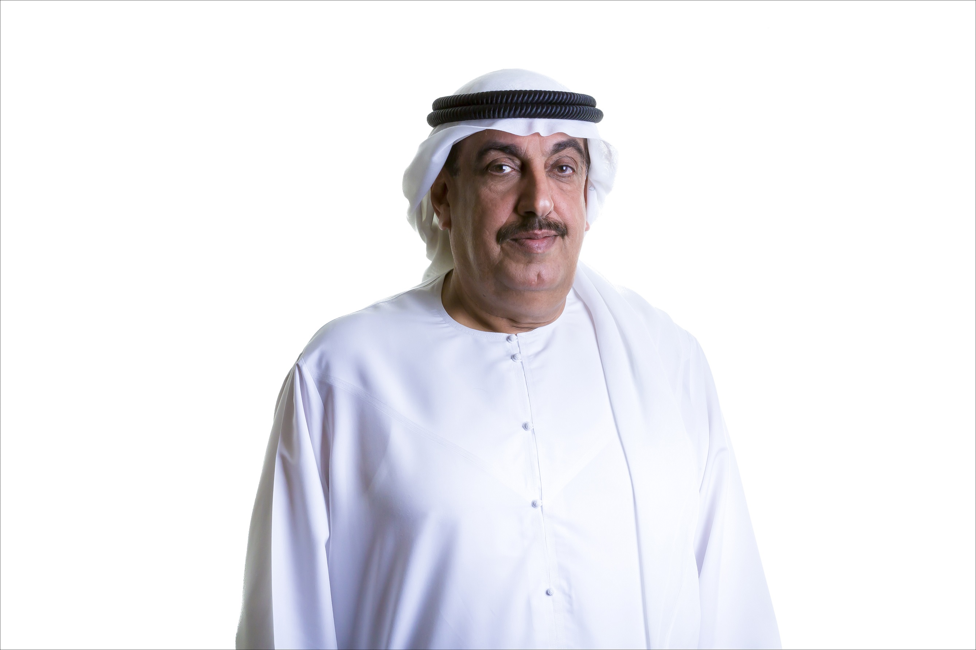

His Excellency Saif Humaid Al Falasi, Group CEO, ENOC, said: “As a founding strategic partner, ENOC has supported DSF for over two decades. ENOC has been part of DSF’s success story since its inception and continues to grow to promote and support the vision of His Highness Sheikh Mohammed Bin Rashid Al Maktoum, UAE Vice President and Prime Minister and Ruler of Dubai, to position the Emirate as the region’s retail, tourism and lifestyle hub.

“We continue to look for ways to reward our loyal customers and DSF is a strategic platform to achieve this goal as it continues to attract new visitors from all over the region. This year was no exception. With a total of AED 19 million in prizes, we witnessed a 15 percent increase in sales thanks to a number of exciting offers that are designed to reward our customers for their shopping experience.”

Carpet & Art Oasis
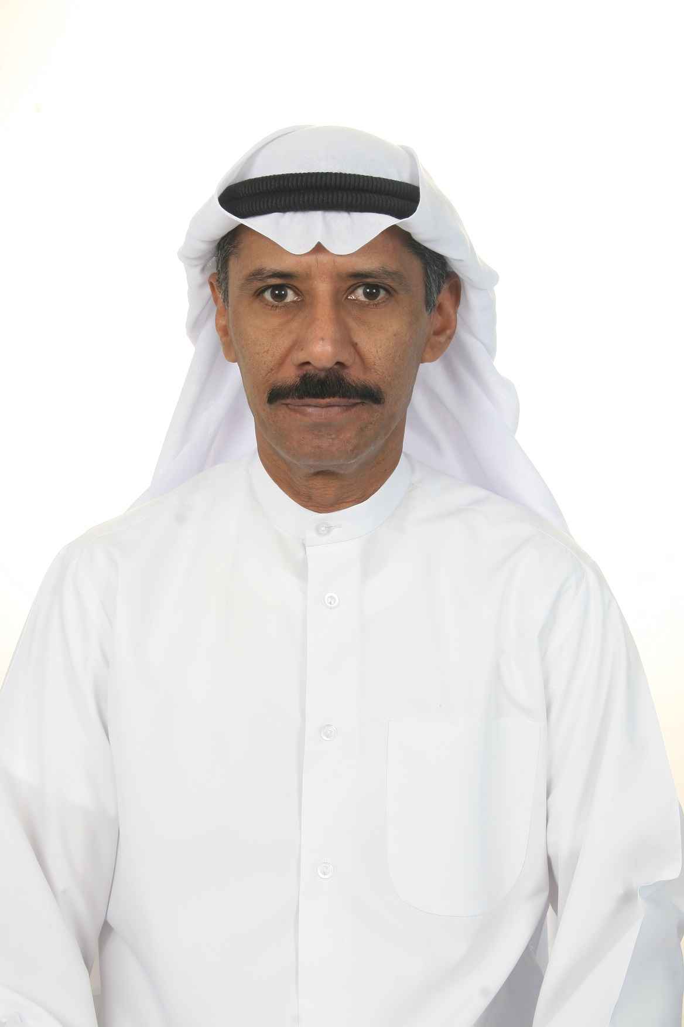

Abdul Rahman Issa, Chairman of the Carpet Oasis Organising Committee, said: “The first two weeks of the Carpet & Art Oasis attracted more than 5,000 visitors while 3,000 carpet items worth more than AED 5 million were sold during this period. Carpet & Art Oasis, which started on 29 January, features 200,000 carpet items, worth AED 2 billion including some antique and historic pieces that date back to more than 400 years and were exclusively brought to the event from Iran and Azerbaijan.”

Financial services

Visa

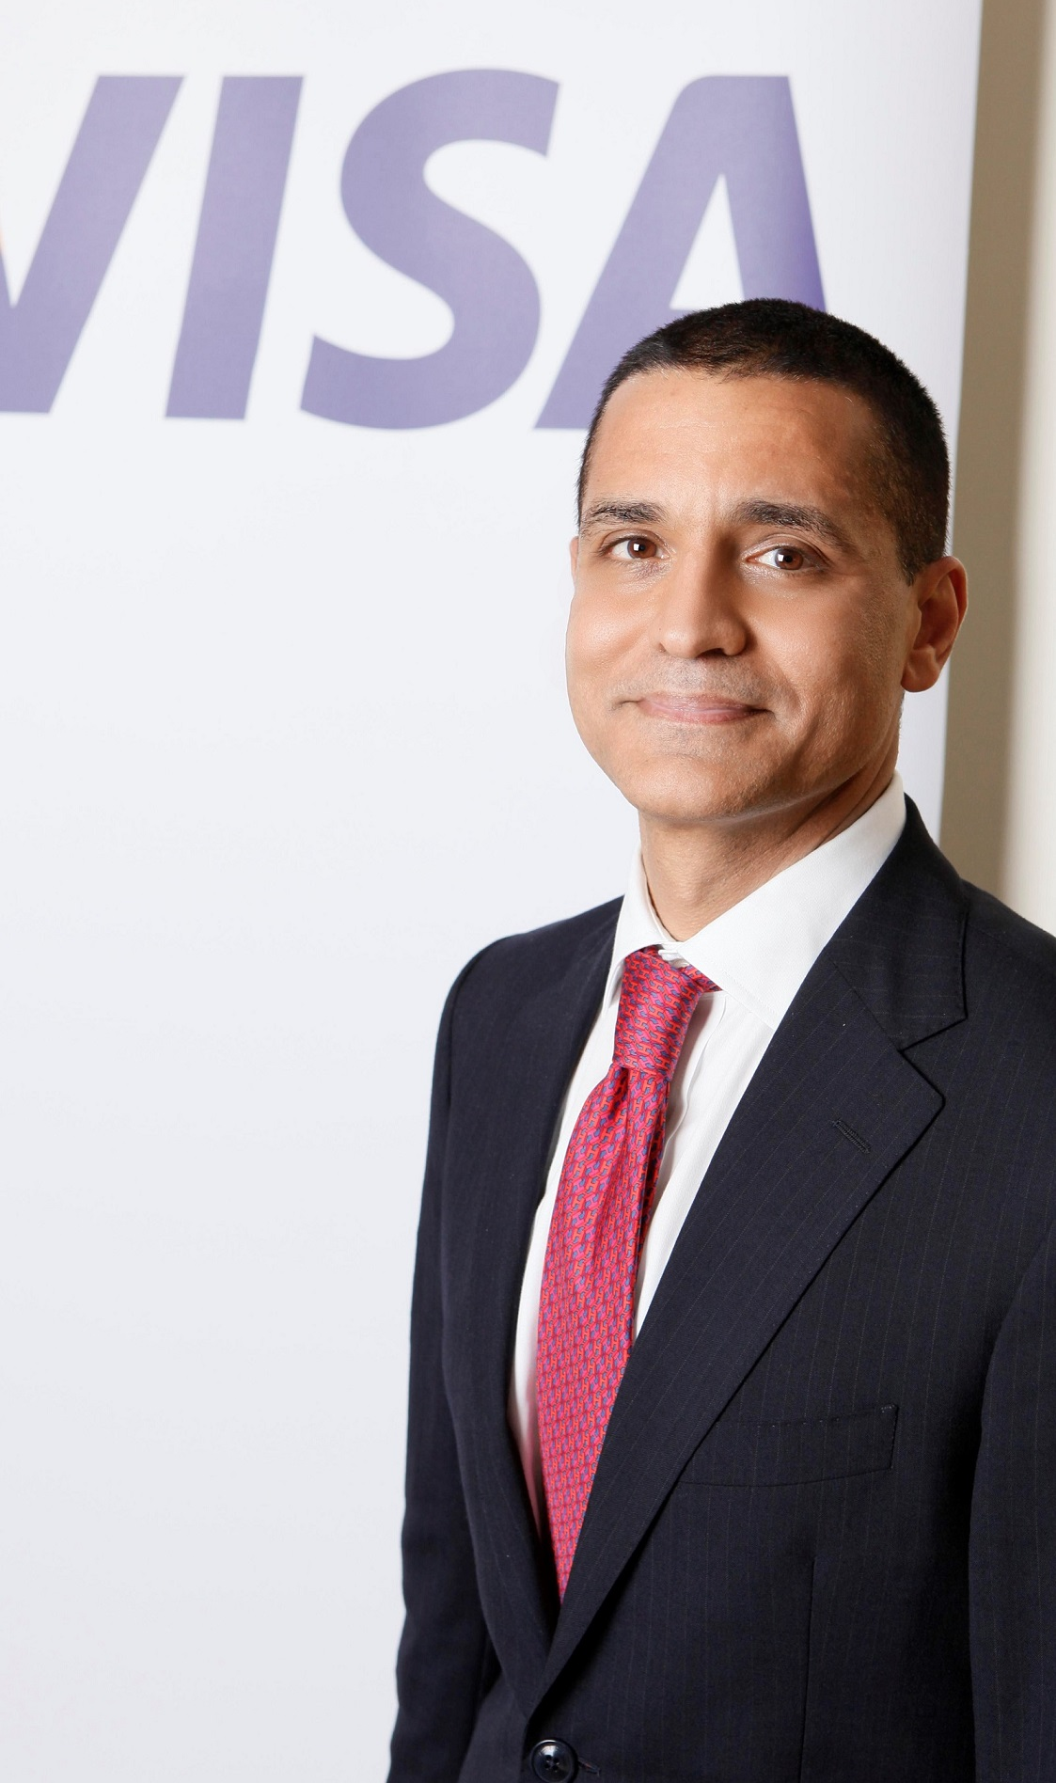

Karim Beg, Head of Marketing for Visa in MENA said: “DSF has yet again proved to be the region’s foremost shopping event with its success running for more than 20 years. More and more consumers are also interested in grabbing our daily offers with the Visa Impossible Deals including cars, gold, watches, IPhones and other luxury items. During this time, we are seeing a significant increase in the confidence of shoppers in using a secure payment such as Visa over cash especially for big ticket items. Shopping cashless has been more convenient this season as consumers get to spend more time choosing products to buy rather than queuing up in cash machines.”

Money exchange house sees 15-20 % increase

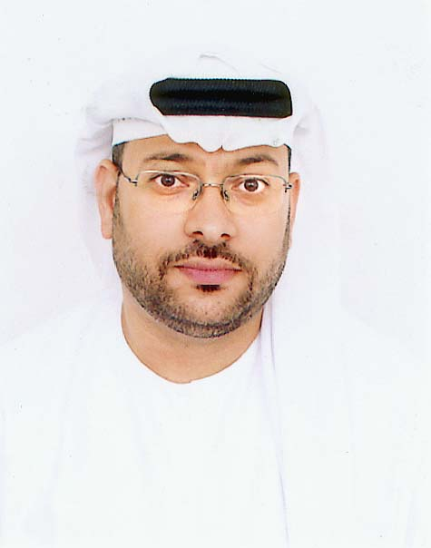

Osama Hamza Al Rahma, Chief Executive Officer at Al Fardan Exchange, said: "Dubai has become a global destination for people from around the world and not just regionally. Given the festival's huge popularity, Dubai is experiencing a higher volume of tourists since the beginning of the year, with a large influx from Saudi Arabia, which is creating a positive impact on the business at exchange outlets and on currency exchange transactions - eventually contributing to Dubai's economy. We have witnessed an increase in our business, especially in shopping malls as a result of growing number of tourists visiting our outlets. Currency exchange transactions have increased in the first two weeks of DSF by 15-20% compared to the same period last year.”

Hospitality

Radisson Blu Hotel

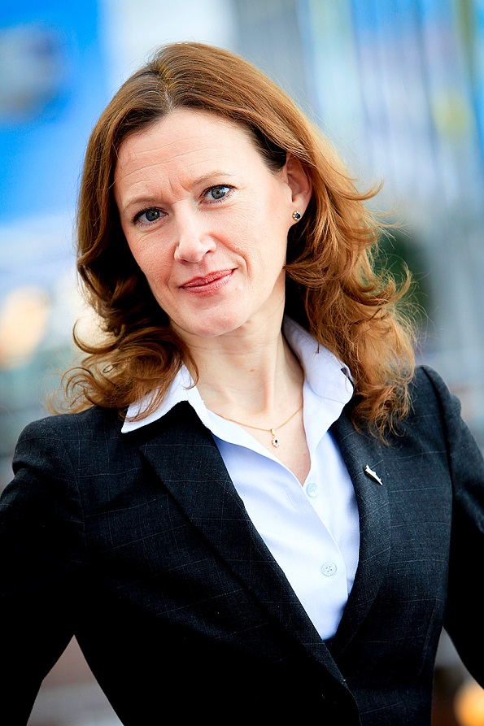

Maria Tullberg, General Manager Radisson Blu Hotel, Dubai Deira Creek, said: “We have been experiencing occupancies in excess of 80% for the last two weeks in December and beginning of January with demand for stays that exceed 3-4 nights’ with the majority of our guests coming from UK, KSA and USA. DSF is a great benefit to the city and I have personally seen many guests coming back to the hotel with their hands full of shopping bags.”

Millennium & Copthorne

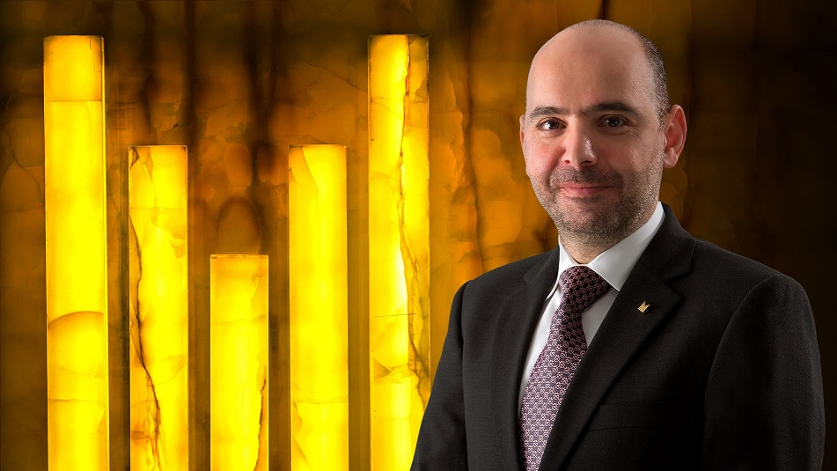

Francois Kassab, Chief Operating Officer, Millennium & Copthorne, Middle East & Africa, said: "Throughout Dubai Shopping Festival, the city attracts an influx of shoppers from both the GCC and further afield who are looking for a convenient place to stay that offers value for money. With four hotels across Dubai, this presents us with significant opportunities to welcome visitors which in turn boosts occupancy levels during this period. All of our hotels in Dubai are centrally located, with an option available to suit every requirement and budget, so thanks to efforts from Dubai Tourism in organizing and promoting the festival, this tends to be a busy period for us."

Travel agency registers 10% increase in bookings
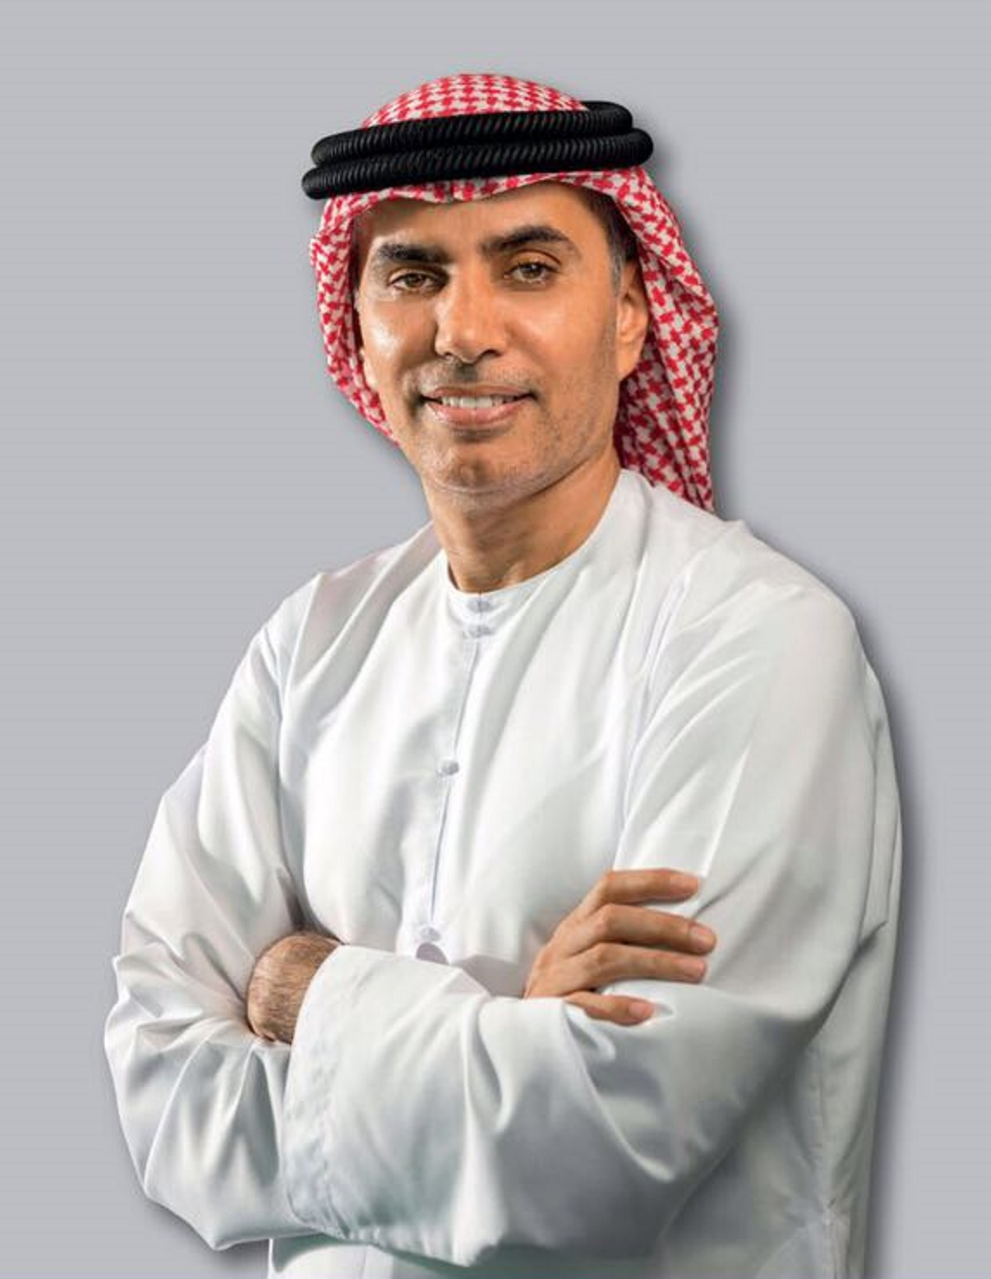

Saeed Alaabdi, Chairman of Alaabdi Holding LLC, said: "The decision to launch the Dubai Shopping Festival one week earlier, before the end of the 2016, was a great move as it coincided with the festive season, traditionally a period that leads to an increase in the purchase of gifts and goods, as well as higher occupancy levels in the hotels. With Dubai Shopping Festival being vibrant as usual, we witnessed a 10% increase in travel bookings to Dubai compared to the same period last year, mostly from GCC, other Middle East countries, and Russia.”

For full details of the calendar of events at DSF 2017 visit

http://www.visitdubai.com/en/discover/festivals/dubai-shopping-festival#highlights

- ends -

About Dubai’s Department of Tourism and Commerce Marketing (Dubai Tourism)

With the ultimate vision of positioning Dubai as the world’s leading tourism destination and commercial hub, Dubai Tourism’s mission is to increase the awareness of Dubai among global audiences and to attract tourists and inward investment into the emirate.

Dubai Tourism is the principal authority for the planning, supervision, development and marketing of Dubai’s tourism sector. It markets and promotes the Emirate’s commerce sector, and is responsible for the licensing and classification of all tourism services, including hotels, tour operators and travel agents. Brands and departments within the Dubai Tourism portfolio include Dubai Convention and Events Bureau, Dubai Calendar, and Dubai Festivals and Retail Establishment (formerly known as Dubai Events and Promotions Establishment). In addition to its headquarters in Dubai, Dubai Tourism operates 20 offices worldwide.

FOR FURTHER INFORMATION PLEASE CONTACT:
Dubai Tourism
mediarelations@dubaitourism.ae
[+971] 600 55 5559
[+971] 4 201 7631

