Jumbo Electronics to create unique Dubai Shopping Festival attraction in the shape of a shopping bag featuring 250 kilos of gold!
- ‘World’s Largest Display Of Gold Bars’ at Jumbo Electronics, Mall of the Emirates on 20 January
- Solid Gold PlayStation 4 up for grabs as part of #Jumboisgold campaign during DSF 2017

Dubai, UAE 18 January 2017: This Dubai Shopping Festival (DSF), Jumbo the leading OmniChannel electronics retailer in the UAE teamed up with festival organisers, Dubai Festivals and Retail Establishment (DFRE), an agency of the Department of Tourism and Commerce Marketing (Dubai Tourism), Emirates Gold Refinery, and Brinks Global on an ambitious project to showcase something that has never been seen before by regular mall visitors. The vision was to engage a regular customer with a ‘WOW’ moment and spread the fun of shopping during Dubai Shopping Festival to the world via online.

UAE nationals, residents, tourists and everyone else are invited to see, take pictures and selfies with the ‘World’s largest display of 250 Kilos of Gold bars at Jumbo Store, Mall of Emirates’ on 20th January 2017, Friday.

To make it even more engaging Jumbo has announced that your ‘Selfie or Picture with Gold’ with ‘#jumboisgold’ could get one lucky winner a ‘Limited Edition Solid Gold PlayStation 4’ worth AED 25,000 absolutely free. Customers need to take a selfie with the gold display and #Jumboisgold and upload it on Instagram or Facebook.

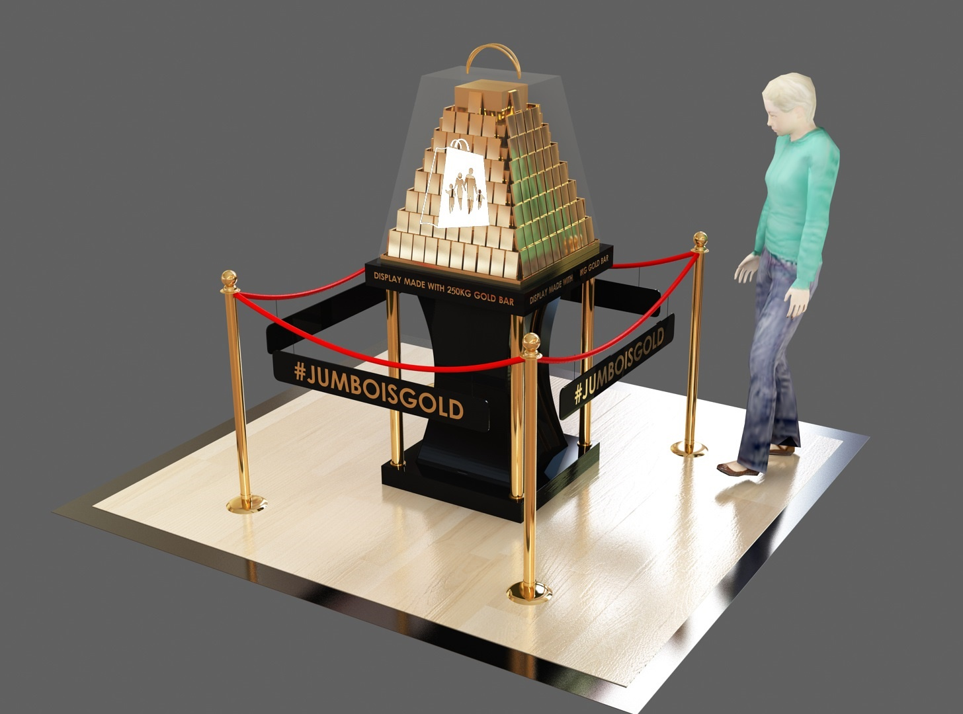

This engagement idea compliments the month long ‘Shop and Win’ DSF promotion Jumbo has across all its stores. Jumbo is giving away ‘Half a kilo gold every week, 10gms gold coins everyday’.

Saeed Mohammad Measam Al Falasi, Executive Director, Retail and Strategic Alliances, (DFRE), said: “Dubai Shopping Festival 2017 is known for offering unparalleled shopping experiences every year that features the best retail offers combined with big winnings and world class entertainment. For the festival’s 22nd edition, we are pleased to provide visitors more opportunities to enjoy memorable moments including this amazing display of gold bars organized in collaboration with Jumbo Group, a longstanding Key Sponsor of the festival. The wholehearted support of leading retailers like Jumbo Group is an essential element for the continuous success and popularity of DSF. The display is not just for shoppers to enjoy but all those visitors with an eye for fashion, style and photography are also encouraged to be a part of the excitement.”

Nadeem Khanzadah, Head of OmniChannel Retail, Jumbo Group, said: “We are proud and privileged key sponsors of the (DSF) for the past 22 years. Giving away gold every DSF has always been a tradition for us but this year, we wanted to bring an even bigger attraction. We shared this idea with the DSF team and Emirates Gold Refinery, both partners shared the same passion and enthusiasm to do something different. We later got Brinks Global to manage the logistics and we ensured that this gold was safely escorted to the Jumbo Store in Mall of the Emirates.”

Nadeem added: “I assure you that this display of solid gold is going to be ‘WOW’, so visit Jumbo store, Mall of the Emirates on the 20th of this month and be ready to take pictures.”

Rami Shakarchi, Managing Director, Emirates Gold Refinery said: “Emirates Gold is a precious metal refinery and mint producing gold bars and coins in the UAE since 1991. We have been an active partner with the Government supporting them on various initiatives like the ‘Your Weight in Gold Coins’ and the iconic ‘Vision of Dubai Coins’ in the past. On hearing this idea we were excited and worked on our plans to showcase 250 Kilos of gold worth AED 35 Million and create a unique and magical experience to make this DSF and Dubai memorable around the world.”

The latest edition of DSF, which commenced on 26 December, runs until 28 January under the theme ‘Shop. Win Celebrate’.

-Ends-

About Jumbo Electronics Co. Ltd (LLC):
Established in 1974, Jumbo Electronics Co. Ltd. is UAE’s leading distributor and retailer for IT and consumer electronics. Since its inception, Jumbo has been the chief distributor of the iconic brand, Sony, in the UAE and Oman. Jumbo is also a trusted distribution and retail partner for many of the world's other leading brands including Acer, Apple, Asus, Alcatel, Blackberry, Brother, Casio, Daikin, Dell, Dyson, Gorenje, HP, HTC, Lava, Lenovo, LG, Motorola, Ricoh, Samsung, and Sennheiser. In addition, Jumbo offers quality, affordable consumer electronics from its private label brand, Supra. It has an extensive network of retail stores and service centres spread across the Emirates and a growing distribution and retail presence in Oman, Qatar, Bahrain and Kuwait.

Jumbo launched its innovative online shopping portal, www.jumbo.ae in November 2014, as an online extension of Jumbo’s brick-and-mortar network, showcasing the brand’s definitive retail expertise in local markets. The website features a number of never-before seen features in the region’s consumer electronics industry, including flexible delivery through the ‘Click & Collect’ service, Card-on-Delivery, 2-Click checkout, and other intuitive user experiences.
Jumbo’s Distribution SBU provides specialised services, including Mobility & Solutions for telecom and information technology sectors, as well as specialty consumer goods. The firm’s B2B business focuses on office automation products, managed services and ELV solutions.

Setting new benchmarks in customer service in the markets in which it operates, Jumbo offers uncompromising adherence to quality and unrivalled after-care through Jumbo Serve, its dedicated 70,000sq. ft. service center in Jebel Ali and 24/7 customer hotline 800 JUMBO.

Over the years, Jumbo has evolved its flagship retail, distribution and trading businesses to offer services under diverse verticals such as Enterprise, Logistics, Engineering and Light Manufacturing. Through its multi-discipline approach, Jumbo enjoys a presence in core industries across regional markets, including hospitality, retail, construction, education, healthcare, oil and gas, and financial services.

Brink Global PR Plate
As the industry leader in risk management and secure logistics, Brink’s has safeguarded valuables since 1859. With 150 years of experience, Brink’s offers the utmost quality of service and sets the market standard. Brink’s Global Services (BGS) is the global division of Brink’s, Incorporated, a widely recognized provider of secure logistics solutions. Utilizing our integrated network of worldwide affiliates, BGS offers secure transport and associated security services in more than 110 countries.
With our unsurpassed global footprint, BGS transportation services include armored vehicles, trucks and trailers; secure air and sea freight; air charters (fixed wing and helicopters), and armed messengers.
The Market Leader
For the banks, financial institutions, governments, mines and the diamond and jewelry industries, the Brink´s name is synonymous with trust, integrity, security and top-notch service. We hire and train the best people, we have invested in specially-developed software and telecommunication links, so that we can provide you with the highest levels of security service and accountability”

- ends -

FOR FURTHER INFORMATION PLEASE CONTACT:
Dubai Tourism
mediarelations@dubaitourism.ae
[+971] 600 55 5559
[+971] 4 201 7631

